Codeamica project setup

# Change Window or any OS required ExecutionPolicy

If you dev on window you have to change execution policy to run script, make sure to change back to Default after work

https://learn.microsoft.com/en-us/powershell/module/microsoft.powershell.core/about/about_execution_policies?view=powershell-7.4

Set-ExecutionPolicy -Scope CurrentUser -ExecutionPolicy AllSigned

Set-ExecutionPolicy -Scope CurrentUser -ExecutionPolicy Unrestricted

Set-ExecutionPolicy -Scope CurrentUser -ExecutionPolicy Default

# Install Node Version Manager(NVM) and Node Version 20 LTS

# Install VS Code

# Add VS Code Extensions(Optional)

## Tailwind CSS IntelliSense

<https://marketplace.visualstudio.com/items?itemName=bradlc.vscode-tailwindcss>

edit vs code settings:

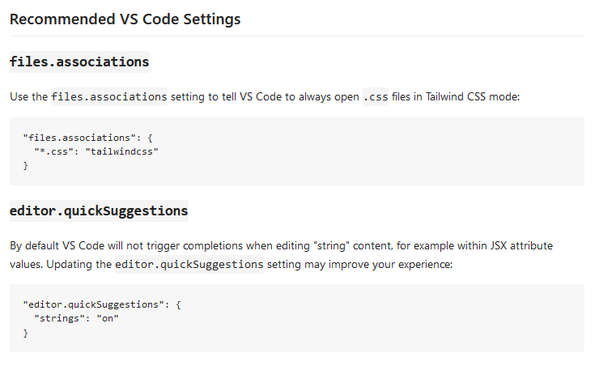

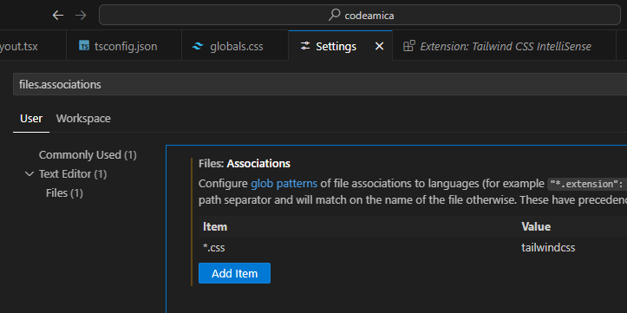

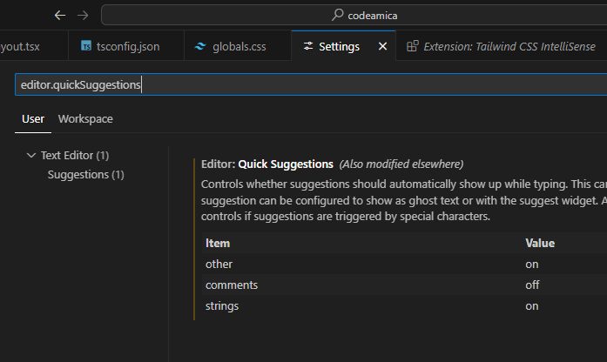

## Inline fold

<https://marketplace.visualstudio.com/items?itemName=moalamri.inline-fold>

# Install React Developer Tools

<https://react.dev/learn/react-developer-tools>

# Clone project from github

After cloning from github open project folder with vscode.

Install required dependencies by using “npm install” command in vscode Terminal.